**The cReg™ Course Registration System Proposal Document**

**Vision:**

cReg™ is an application that enables university students to efficiently and effectively register for courses and view their courses over the internet.

**Motivation:**

The need for this software arises from the fact that existing registration systems do not sufficiently satisfy the needs of current students. One major deficit is that students are required to register for courses on registration day, leading to long wait times for students that urgently need to register. Further compounding the issue, not all students have access to high-speed internet which otherwise might help alleviate some of the delays. Therefore, those students without fast internet face the possibility of being unable to complete their degree requirements due to circumstances outside of their control. Not only does this negatively impact the student, but it also negatively impacts the university's ability to serve its students.

cReg™ will resolve this problem by enabling students to add courses to a shortlist before the registration date so that they will automatically be registered in the courses from their shortlist on the registration date. Not only will this reduce instances of students being unable to register for a course they need or want due to a slow internet connection (which has nothing to do with their standing as students), but it will also provide university administration with a method of efficiently predicting the number of seats needed for a given course (with which they could make planning decisions regarding lecture hall assignments to courses), thus reducing the workload of registration services administration and improving the ability of the university to provide services to students.

Another important feature that sets cReg™ apart is the fact that it comes with the capabilities of a digital advisor, which can inform student decisions regarding course selection. Not only will this advisor reduce the number of trivial appointments with student advisors, allowing these advisors to focus more time on more difficult advisory matters, it will also grant students a convenient and easy method of verifying and planning for their future.

Paired with the course shortlisting system, the digital advisor will allow students using cReg™ to better leverage the capabilities of the digital age to their advantage by reducing registration hurdles and helping students plan forward. cReg™ will also enable university administration to leverage available data for planning purposes and free up the time of advisors so that they may allocate their time helping solve more pressing concerns.

**The criteria used to judge the success of cReg™ are:**

1. The time taken for a student to register for 10 courses in 2 different terms is at least 50% faster than the current system.
2. Students can register for their courses using the recommendation system in just one click per course.
3. The advice given by the digital advisor is judged as effective, useful, and objectively correct by current students.

**Features:**

1. Course Recommendations (eAdvisor/Virtual advisor)
   1. Analyses what students take in their degree year
   2. Offers potential schedules (templates)
   3. Attempts to distribute students across classes
   4. Tells the student what their requirements are for their current or desired degree
   5. Tells the student if a course they are looking at fulfills any criteria
   6. Course ratings
   7. Course outcomes and Grade distributions
2. Course wishlist before registering, students can add courses to their wishlist

. At registration time, the system attempts to register for all the courses.

i.Allow the user to sort based on priority

1. Ability for courses to be added to the user's personal calendar (export calendar)

**Server choice:**

* AWS EC2

**Server justification:**

* The recommended choice from Professor Braico.

**Framework choice:**

* .NET Framework (C#)

**Framework justification:**

* Team members were already familiar with C# and .NET framework so we would be able to spend more time implementing solutions and less time trying to learn the language
* Other members who weren’t familiar wanted to learn these technologies
* Plenty of API support and documentation for .NET (MS website is full of documentation). Additionally, due to its popularity, informal support and documentation are plentiful.
* .NET is broadly used in many of the companies as their framework to develop mobile and web applications which are good to be exposed to the .NET environment before graduation.
* .NET support cross-platform mobile development tool ‘Xamarin’ can allow the developer to create one code base which will create apps for both iOS and Android.
* .NET supports the new UI toolkit ‘Blazor’ which seems to be a good front-end framework for application development.
* .NET has strong tools for web application development, especially the PWA (Progressive Web Application), which could be the future trend of web application development.
* It also has many different options to choose from, including ASP.NET MVC, Web API, and others which gives us flexibility if one seems better for our vision than another.
* It has been done on AWS before and the cohesion between them seems to be adequate for our purpose

**Data Storage Technology:**

* AWS RDS - more specifically MS SQL (Relational DB)

**Data Storage Justification:**

* Storing information about classes and students makes sense to have a more rigid schema and so we chose a built-in relational database system from Amazon.
* We are using a framework from Microsoft so we decided that we would remain with Microsoft for our DB since their documentation is good and the cohesion between the framework and DB would be beneficial.

**Project management**

We choose Github so that we could minimize the destinations we need to visit while working on the project. In addition, we are also very familiar with this service, hence, we will have more time to develop software rather than adapting to other project managing techs.

**Github link:**

**User stories:**

* As a student, I want to be able to see the course-list so I can register for the courses I want to take
  + Time estimate: 3 days
  + Priority: Very High
* As a student, I want to be able to register for courses on my phone, so I don’t have to open my laptop (or go to school)
  + Time estimate: 3 days
  + Priority: Very High
* As a user, I want to see my course schedule
  + Time estimate: 5 days
  + Priority: Very High

* As a user, I want to see the recommended courses
* Time estimate: 10 days
* Priority: High
* As a user, I want to have a course wishlist before registering so I can automatically register courses from the wishlist
  + Time estimate: 10 days
  + Priority: High
* As a user, I want to export my course schedule to my personal calendar
  + Time estimate: 12 days
  + Priority: High

* As a user, I want to see the course’s rating, so I could choose courses better
* Time estimate: 5 days
* Priority: Medium

* As an admin, I want to add a course to the course-list from the website or phone app, so I don’t have to go to the school office
* Time estimate: 2 days
* Priority: Low

**Data Model Diagram:**

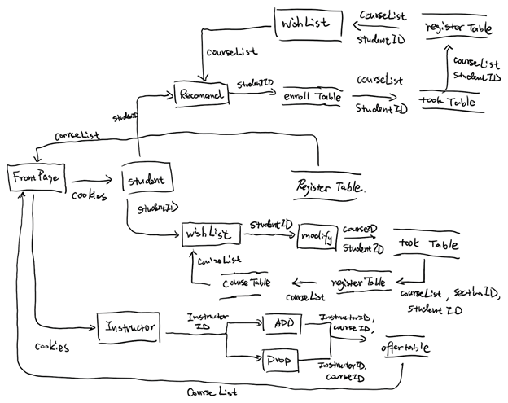

**ER Diagram:**

